August 2021

Dear New East-West Center Students:

On behalf of the Education Program, East-West Center staff, and current participants, I welcome you to your new home in Hawai‘i and the East-West Center community.

As new participants joining the East-West Center ‘ohana (extended family), you will have an opportunity to get acquainted with each other throughout the Community Building Institute. You will also meet many continuing EWC students who are volunteering their time to assist you.
Useful tips and information to help you with the settling-in process is available at our Participant Information site (https://ewcparticipantinfo.org), which includes information and links regarding shopping, EWC housing, financial services, TheBus (city transportation), dining, and other aspects of life and living in the Center and Honolulu. The Student Portal section of this site will be your one-stop-shop for information about the Education Program, including our important COVID-19 policies. I encourage you to bookmark it now. All the materials in this packet and information about CBI are also available on the site, specifically at this link: https://ewcparticipantinfo.org/cbi.

If you are already familiar with the University of Hawai‘i at Mānoa and the East-West Center, you can share your insights with those arriving in Honolulu for the first time during the Community Building Institute activities.

Again, welcome to the East-West Center. We are delighted to have you joining us during this difficult and unusual time. It is in times like these that a community like ours becomes more important than ever.

With warm aloha,

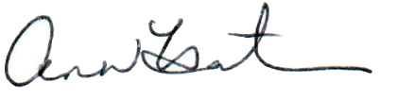

Ann Hartman
Dean

